**CURRICULUM VITAE**

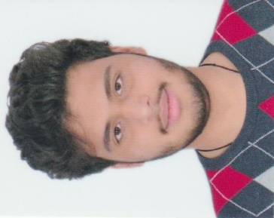**Personal details**:

* Name: Elyas Abdulredha Mohamed Yusuf
* Date of birth: 21 April 2001
* Nationality: Bahraini
* CPR number: 010406212
* Email: [elyasyusuf04@gmail.com](mailto:elyasyusuf04@gmail.com)
* Contact number: 32323143

**Objective:**

To find a job that matches with my qualifications and looking forward to apply my skills and learning into practice

**Education:**

* 2018 - Graduate from Hamilton Heights High School (United States)
* 2019 - Currently at Polytechnic (Bahrain - major Logistics)

**Core Skills:**

* Smart
* Good communication
* Working under pressure

**Languages**:

* Arabic: Fluent (written & spoken)
* English: Fluent (written & spoken)